Phishmon Hyperparameter Tuning Summary

In an effort to improve the Phishmon Phishing classification models (i.e. Random Forest, AdaBoost, KNN, CART), hyperparameter tuning was conducted with the goal of creating more accurate models. Certificate Feature data was split into train and test sets for both the feature and target data. Feature data included a mixture of integer and boolean data, and was composed of the following features: has_cert, longetivity, valid_cert, extended_validation, cert_age, and multi_mtn. The target variable was a binary variable denoting the class as either “phish” or “alexa.”

Once the feature and target variables were established, data could be input into each model. Base models (i.e. models utilizing default hyperparameters) were initially run with the data to establish baseline classifications for future comparison. With a baseline established hyperparameters could then be tuned using SKLearn’s gridsearch function. Gridsearch allows for the iterative testing of a model’s hyperparameters and can be considered model optimization through brute force. Each model utilized in the Phishmon paper was tuned in this fashion until more optimal parameters were developed. Tuned models were then run with input data to produce new target classifications. The resulting accuracies and confusion matrices of both the baseline models and tuned models can be seen in the figures below.

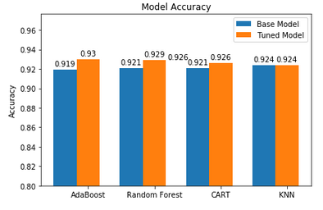

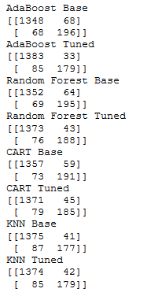

Discussion

Tuning models made slight but consistent improvements to model accuracy. Improvements ranged between 0% and 1.1% increases. Both the tuned random forest and AdaBoost model accuracies did exceed the Phishmon paper’s published accuracy of 92.6% for certificate features when using random forest classification. This indicates that tuning models is useful with respect to the Phishmon dataset, and should be applied to future efforts.